EXP: 8 Create an ARIMA model for time series forecasting
Aim: To create an arima model for time series forecasting using autism screening dataset
Procedure:
1.Import the necessary libraries:
import pandas as pd
import matplotlib.pyplot as plt
from statsmodels.tsa.arima.model import ARIMA
from pandas.plotting import register_matplotlib_converters
register_matplotlib_converters()
2. Load the dataset
df = pd.read_csv("autism_screening.csv")
3. Visualize the data
monthly_positive.plot(title="Monthly Positive Autism Screenings")
plt.xlabel("Month")
plt.ylabel("Number of Positive Screenings")
plt.show()
4. Check for stationarity (ADF test)
from statsmodels.tsa.stattools import adfuller
result = adfuller(monthly_positive.dropna())
print(f"ADF Statistic: {result[0]}")
print(f"p-value: {result[1]}")

5. Fit ARIMA model and Print the summary of the model
model = ARIMA(monthly_positive, order=(1, 1, 1)) # ARIMA(p,d,q)
model_fit = model.fit()
print(model_fit.summary())
6. Visualize the forecast
monthly_positive.plot(label='Actual', color='blue')
forecast_series.plot(label='Forecast', color='red', linestyle='--')
plt.title("Forecast of Positive Screenings for Autism")
plt.xlabel("Date")
plt.ylabel("Number of Positive Screenings")
plt.legend()
plt.show()
OUTPUT:
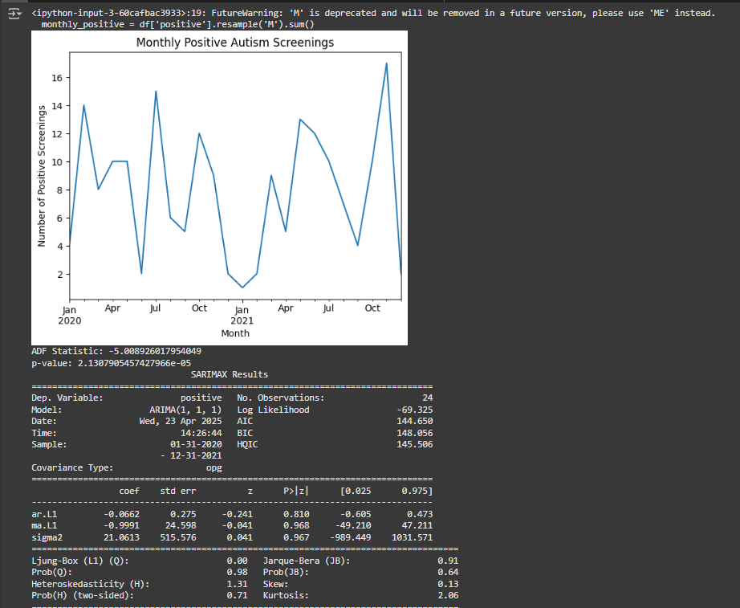

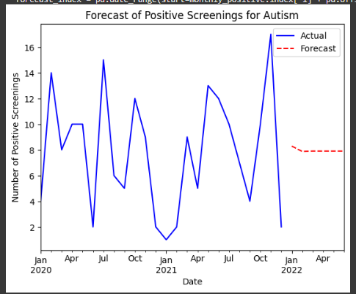

Result: This program to develop an arima model for time series forecasting using autism screening dataset implemented and executed successfully
